Summary for the simulation results

1. Under null1 model, we directly shuffle reference data to get null data set. All methods are good.

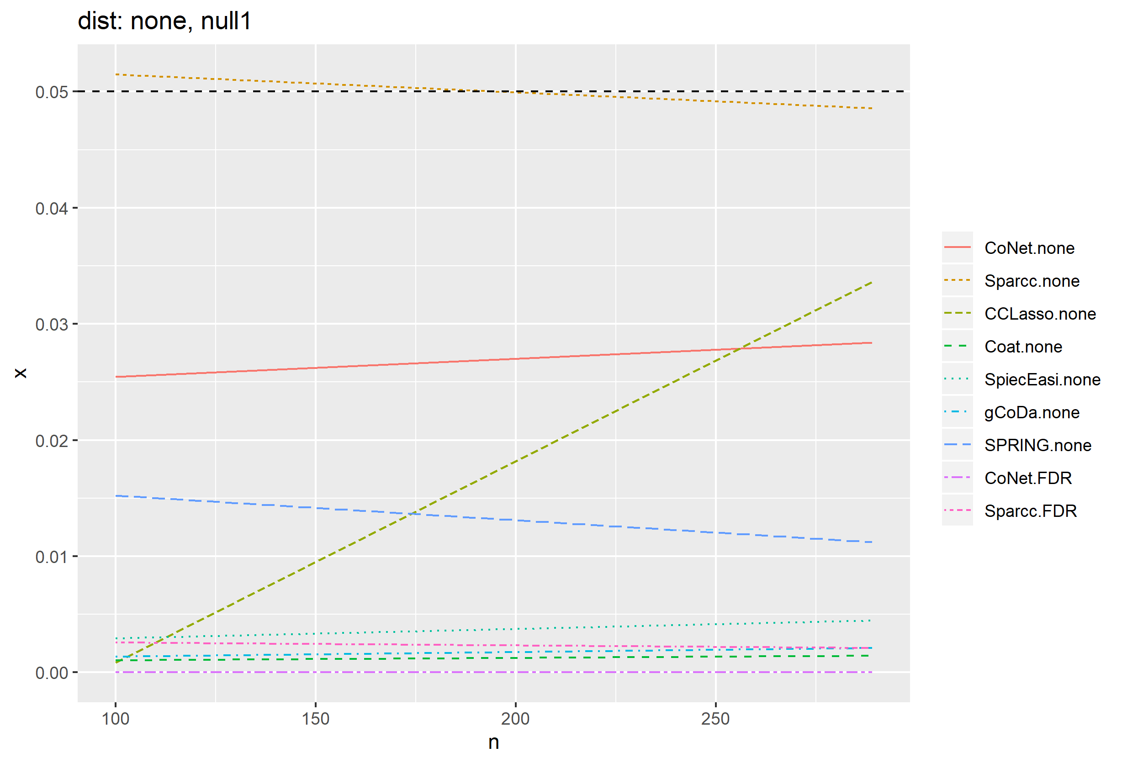

1. Under null1.1 model, we generate data from copula model with a specified marginal distribution. Following plots are for false positive rate.
   1. Zinegbin (zero inflated negative binomial), fix p=200, varying n,

CCLasso has slight problem

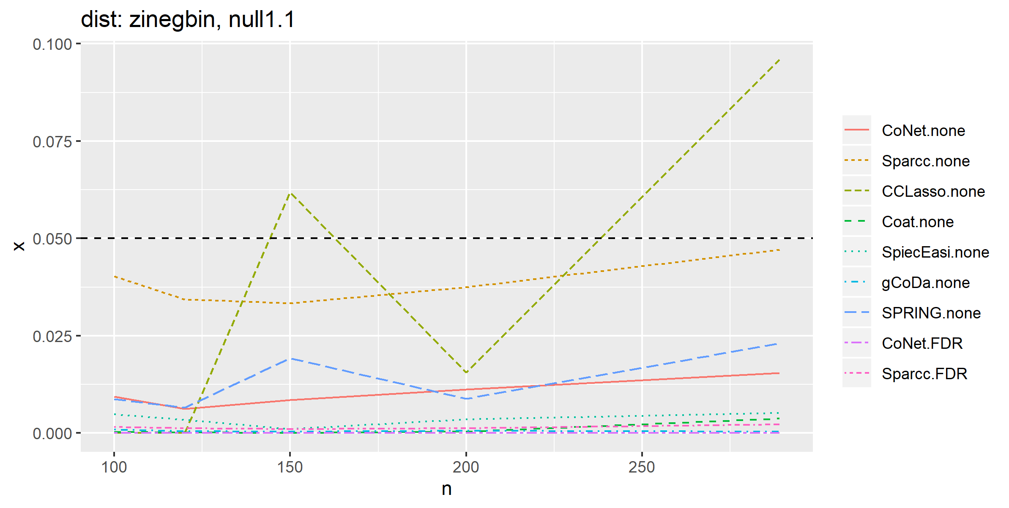

* 1. Pois (poisson), p=200, varying n.

CCLasso, Coat and Sparcc have issues 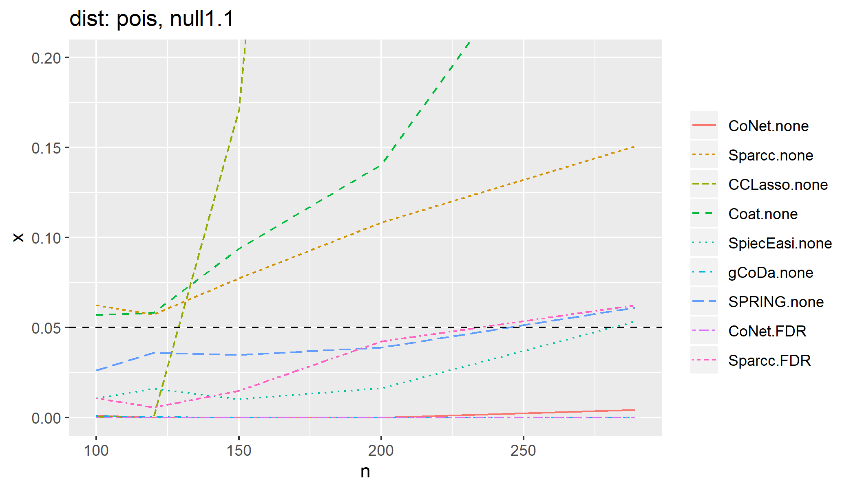

* 1. Negbin (negative binomial), p=200, n varying. All methods are good.

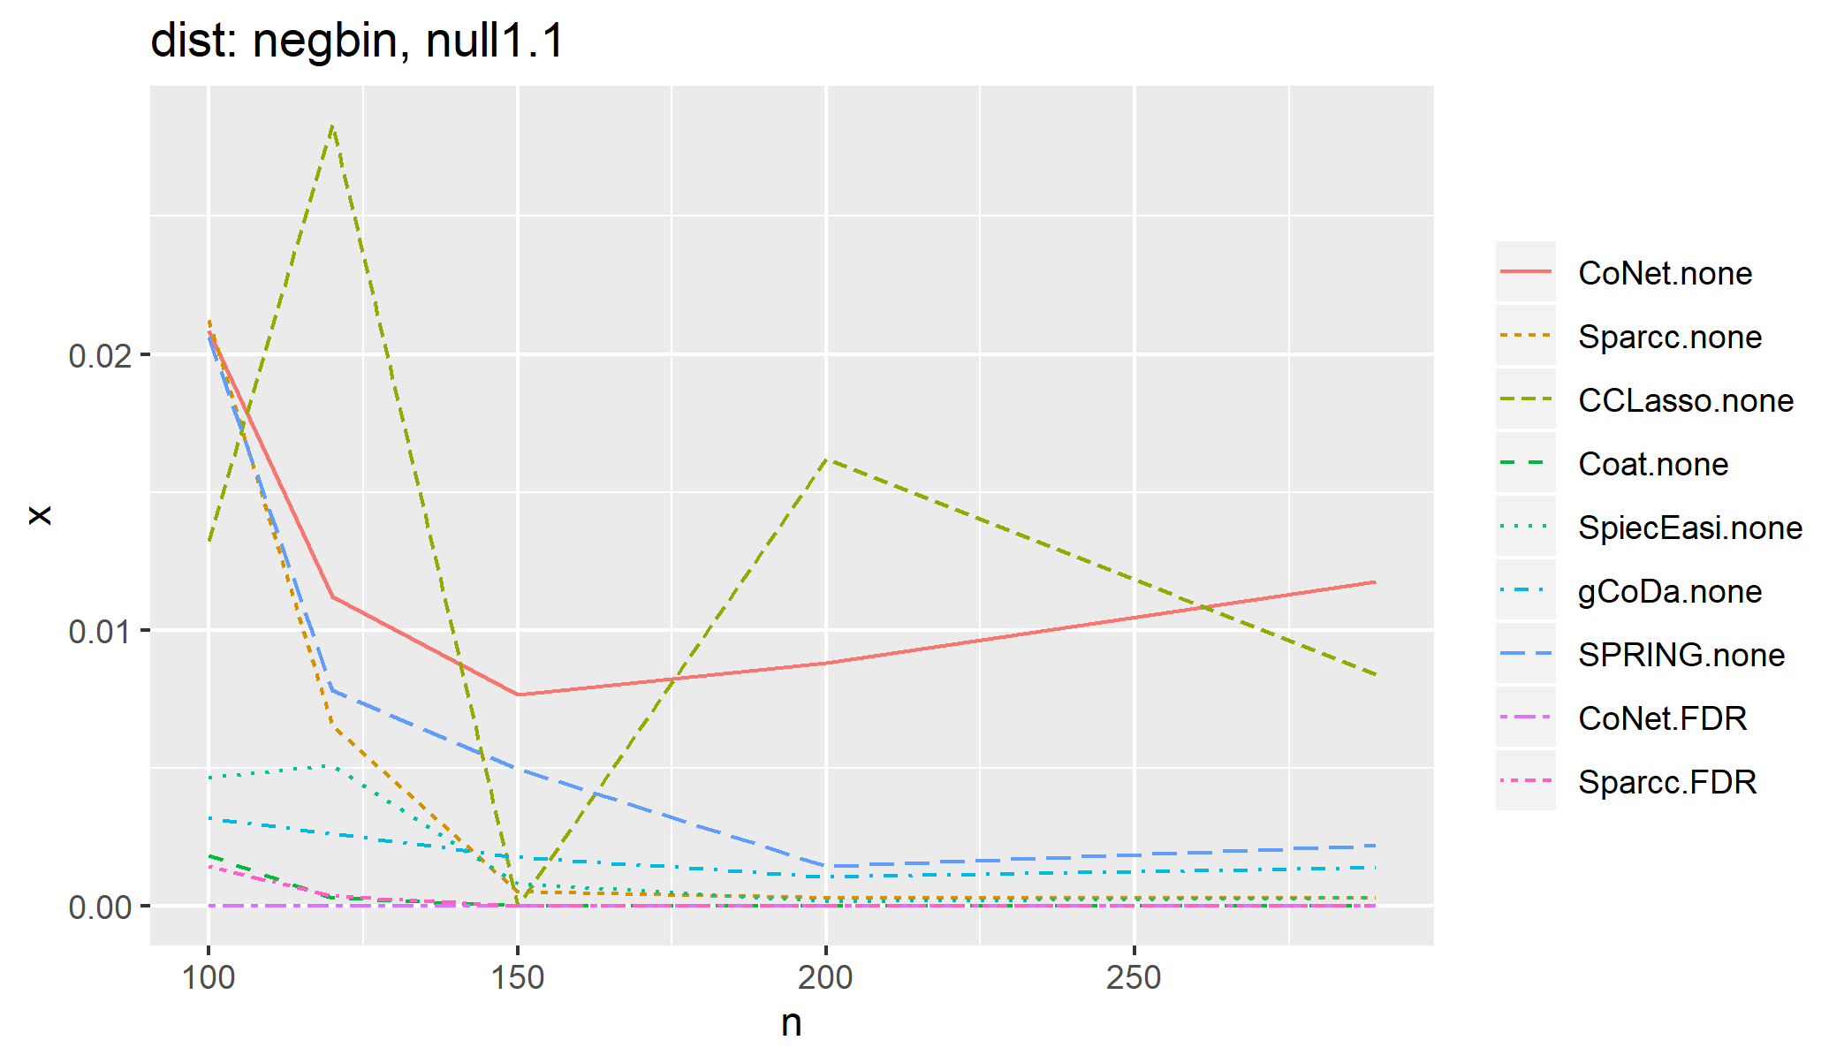

* 1. Had difficulty to simulate from zipois and lognorm (estimation of marginal distribution parameters did not converge).

1. Under null2 model, generate from Dirichlet distribution. n=c(100, 200, 500), p=c(20, 50, 100, 150 200).
   1. use fixN (fixed library size) and also change to rmvnorm function (sorry I made a stupid mistake in my original rnorm function!!! mean mu values were added in a wrong order and things get distorted!!. Fortunately only null2 is affected). Use mu from uniform(0,4):

only Coat and CCLasso fail under p=20

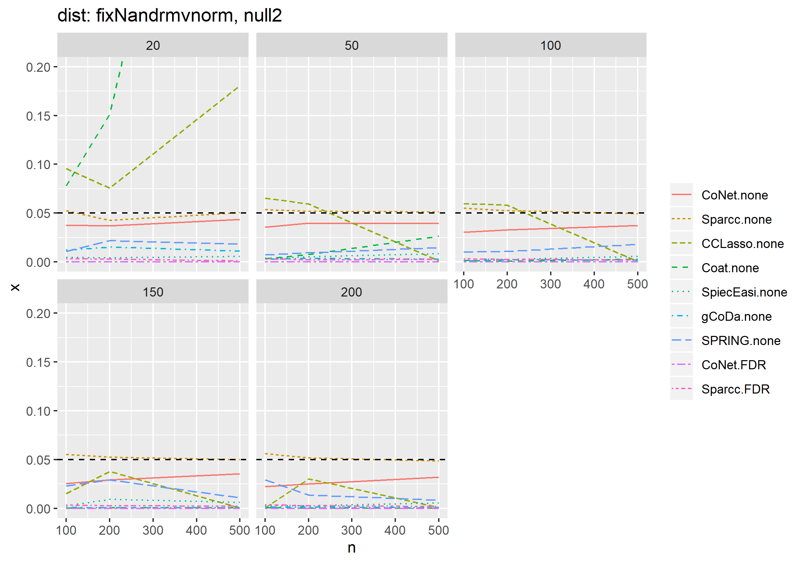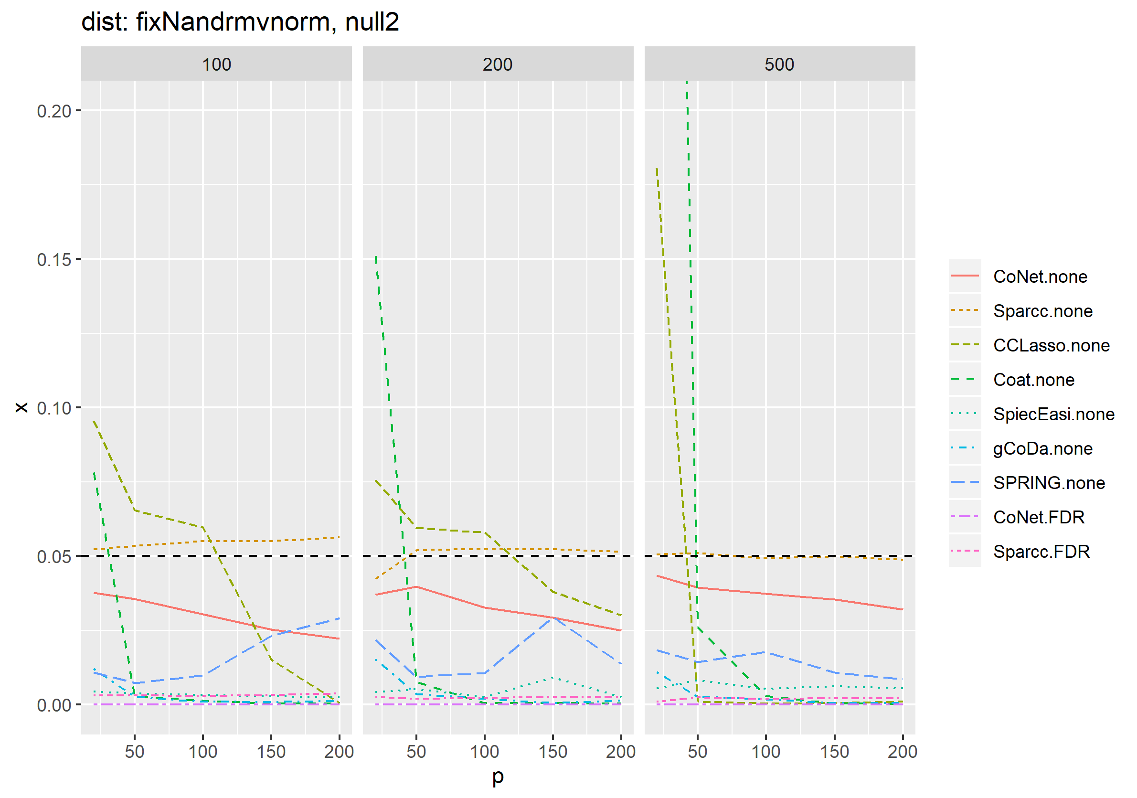

* 1. use fixed library size and use mu~uniform(0,1)

seems does not make much difference compared to mu~uniform(0,4)

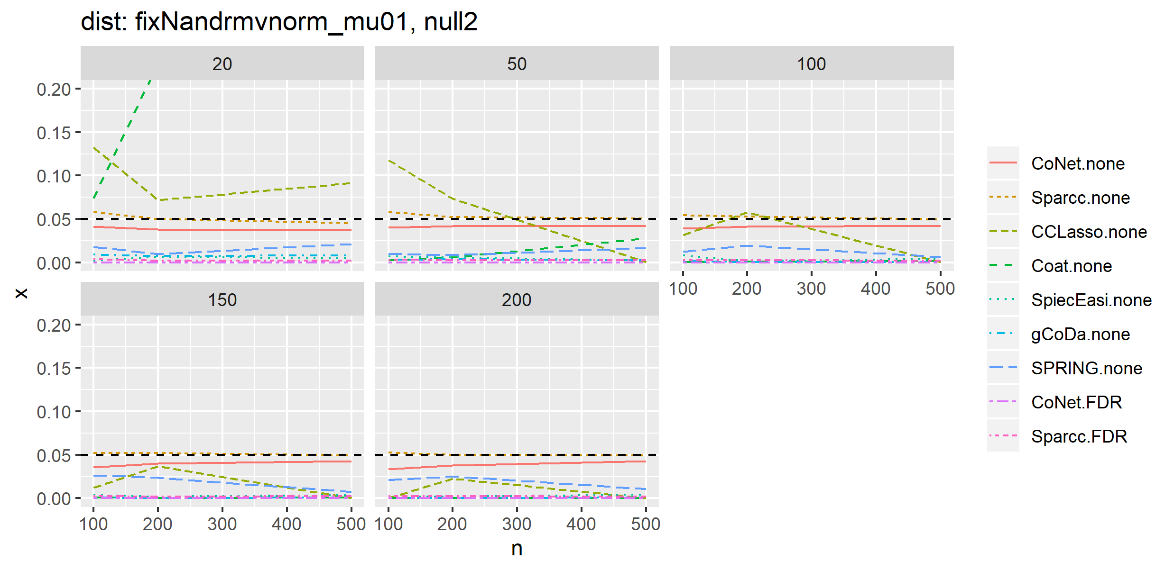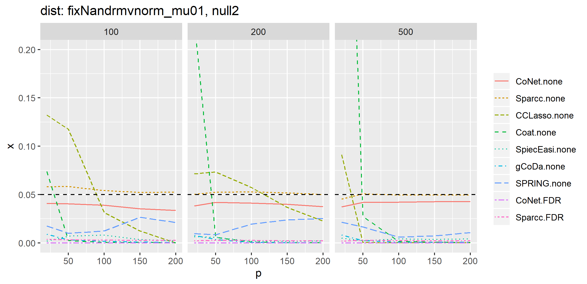

* 1. use varying library size and mu~uniform(0,4)

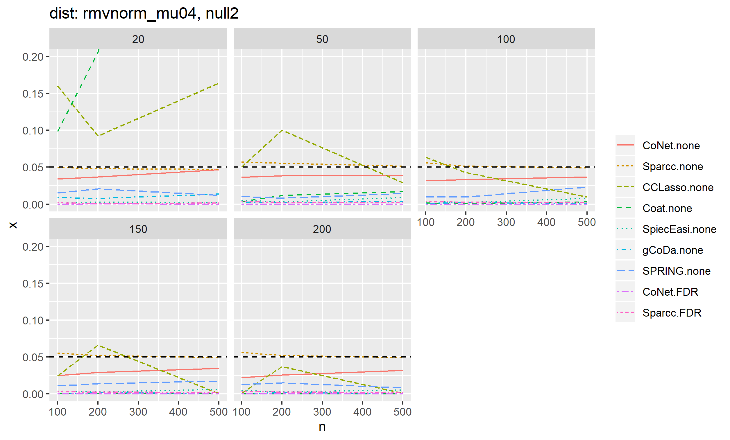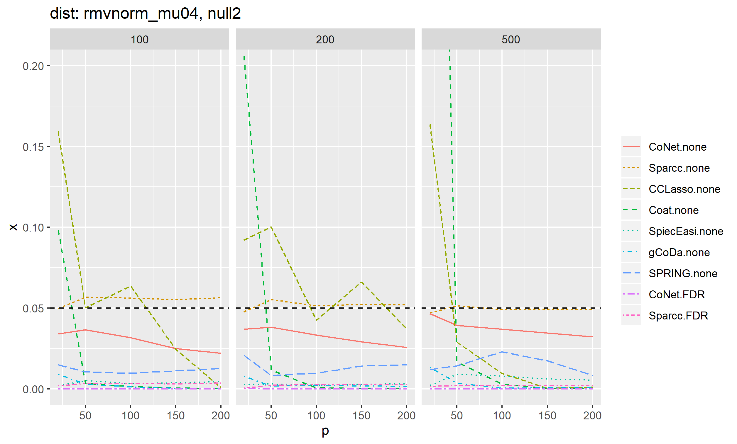

1. under alt1, generate based on copula model, the network is generated from a random graph and is set to be fixed within one setting. We vary marginal distributions. n=c(100, 120, 150, 200, 289), p=127
   1. Zinegbin

The tuning parameter sequence is problematic for COAT

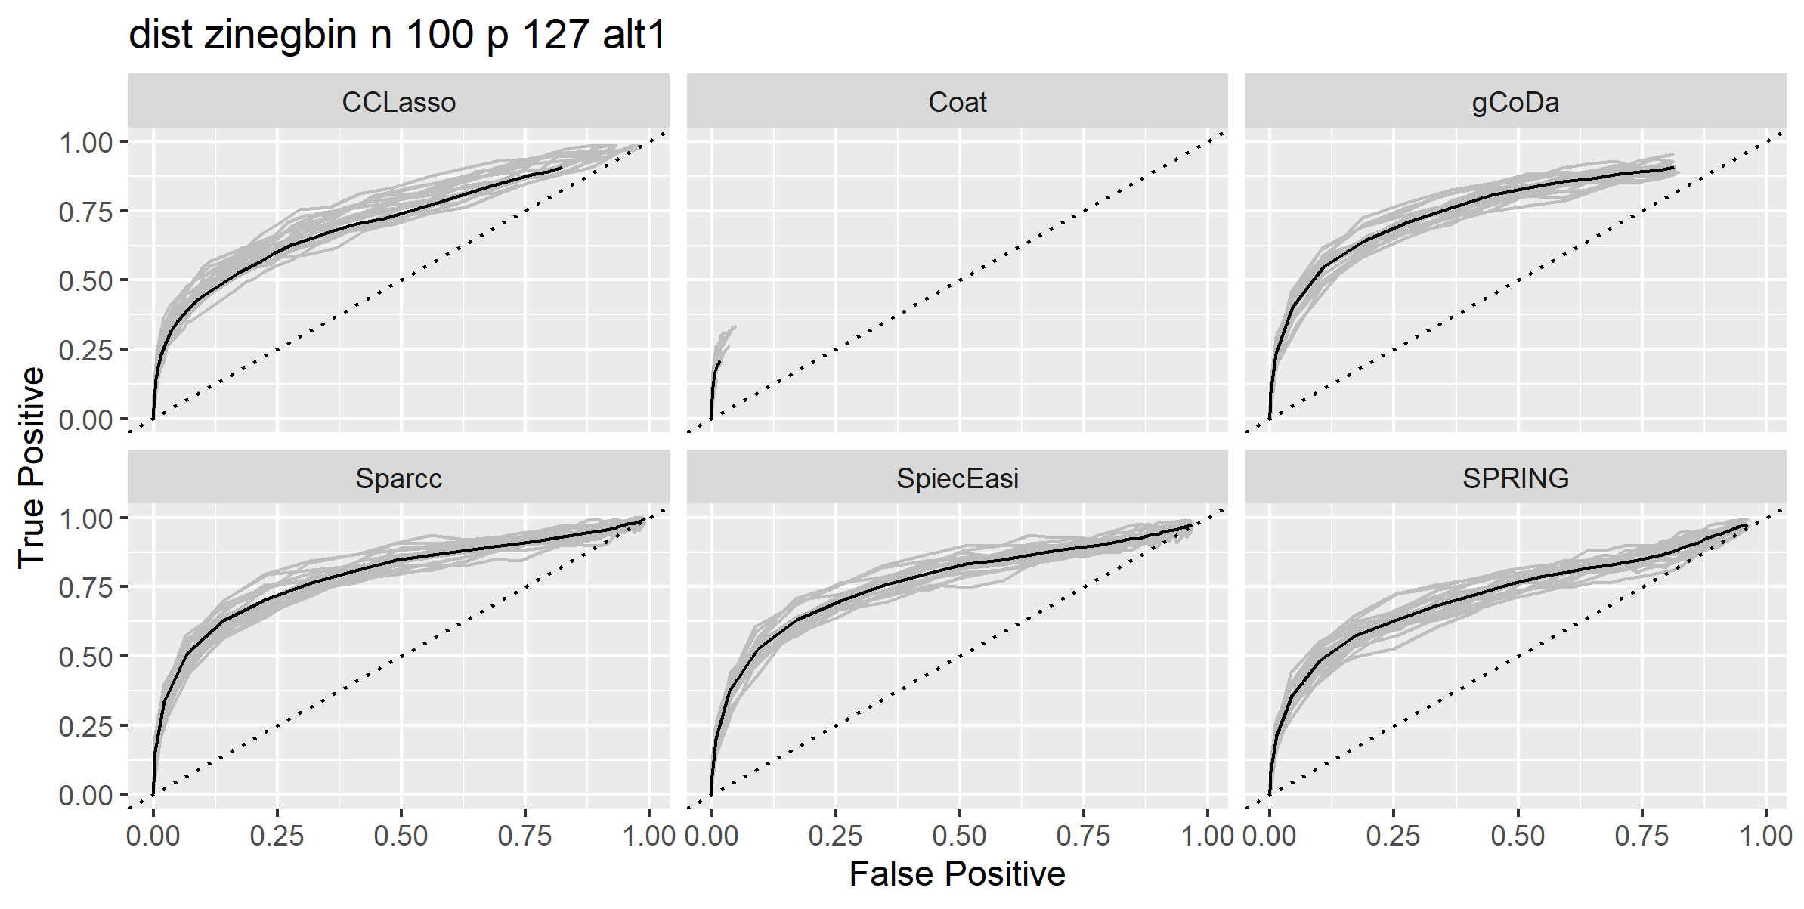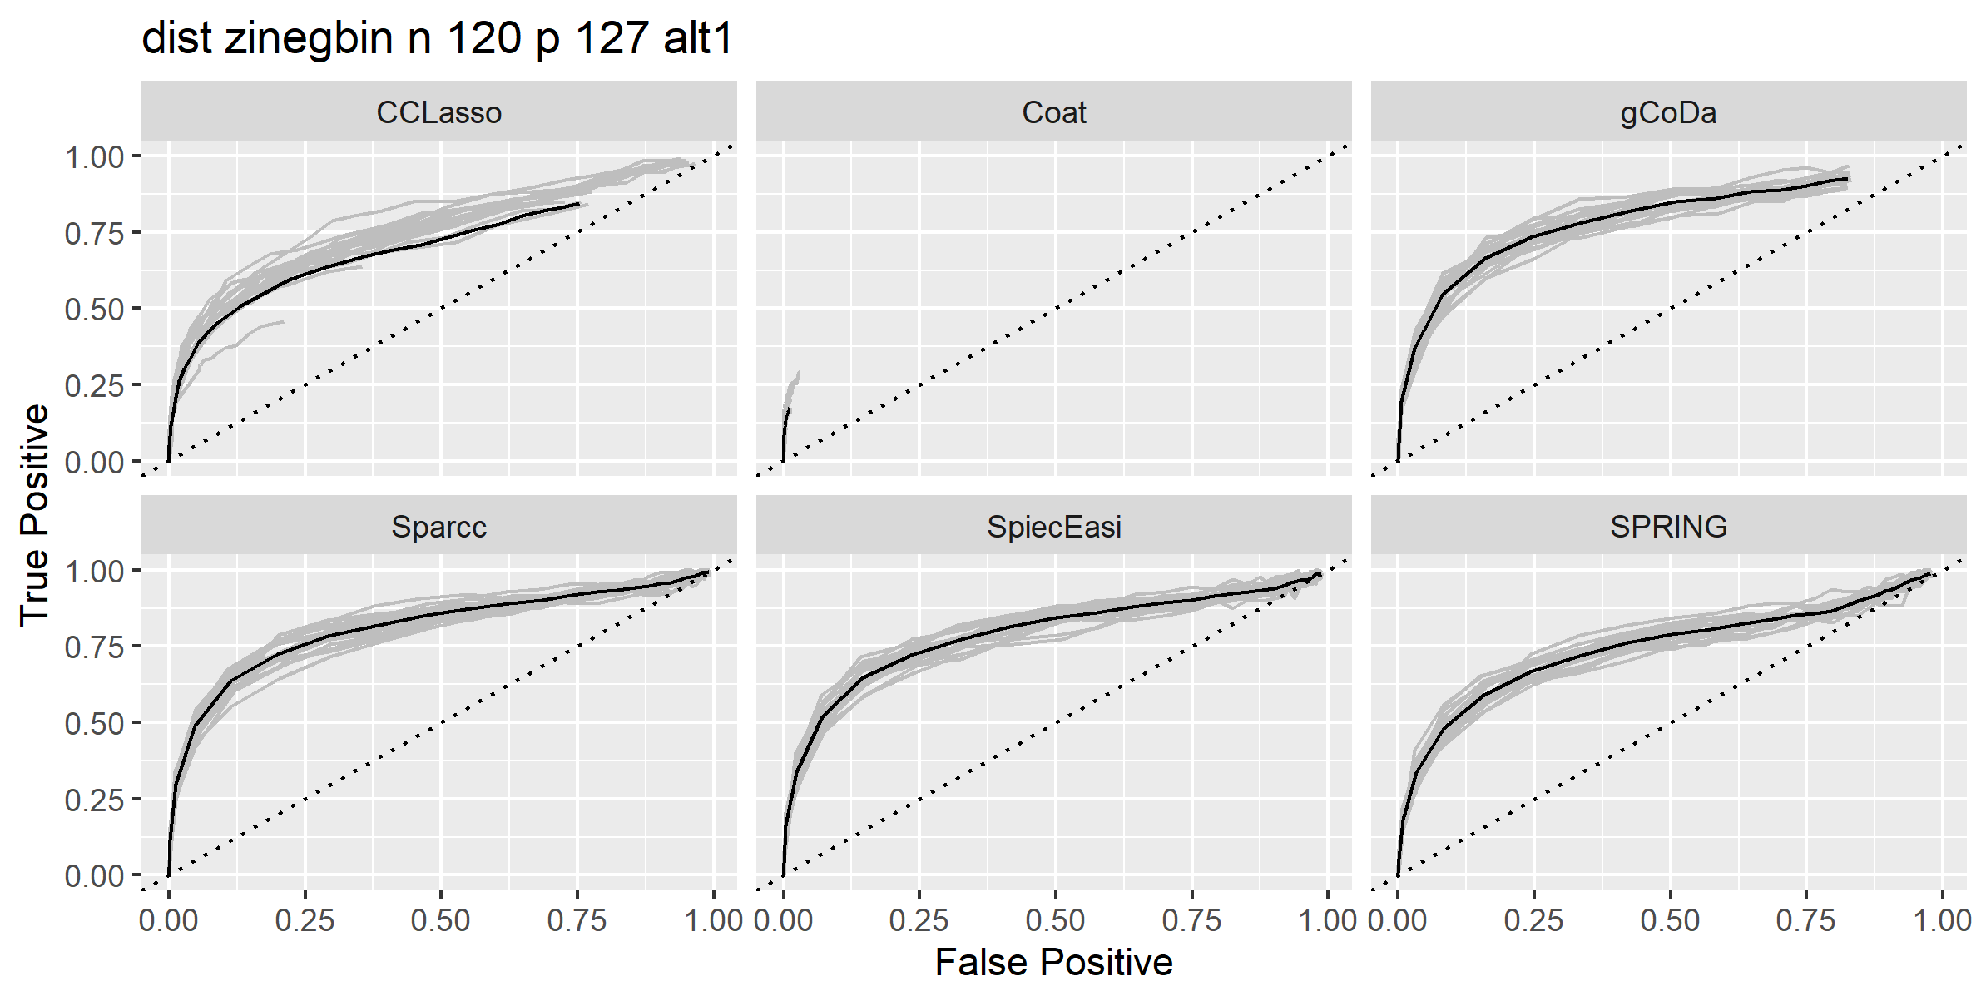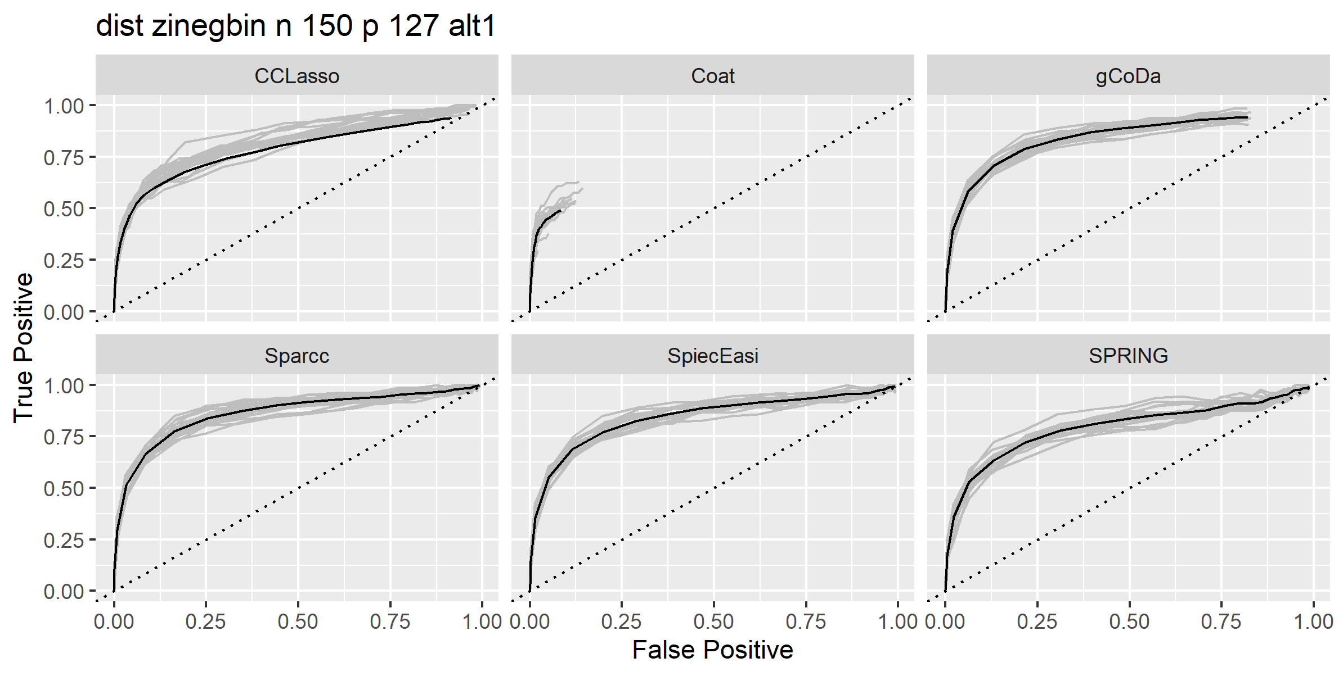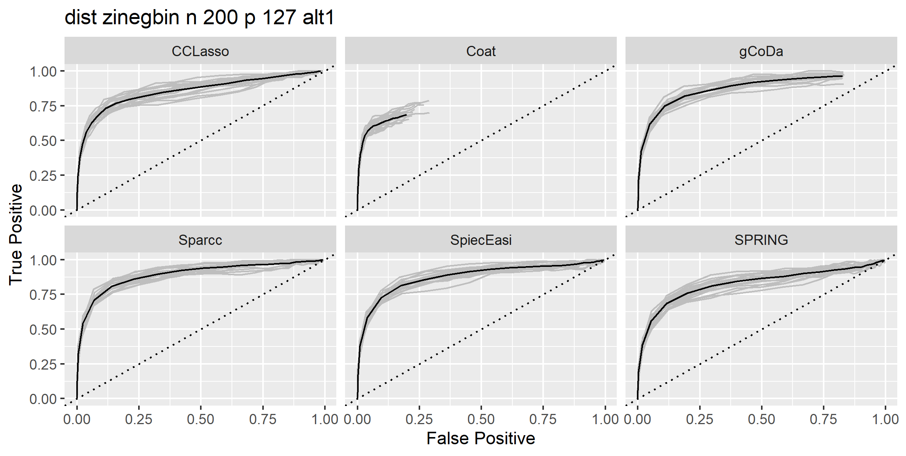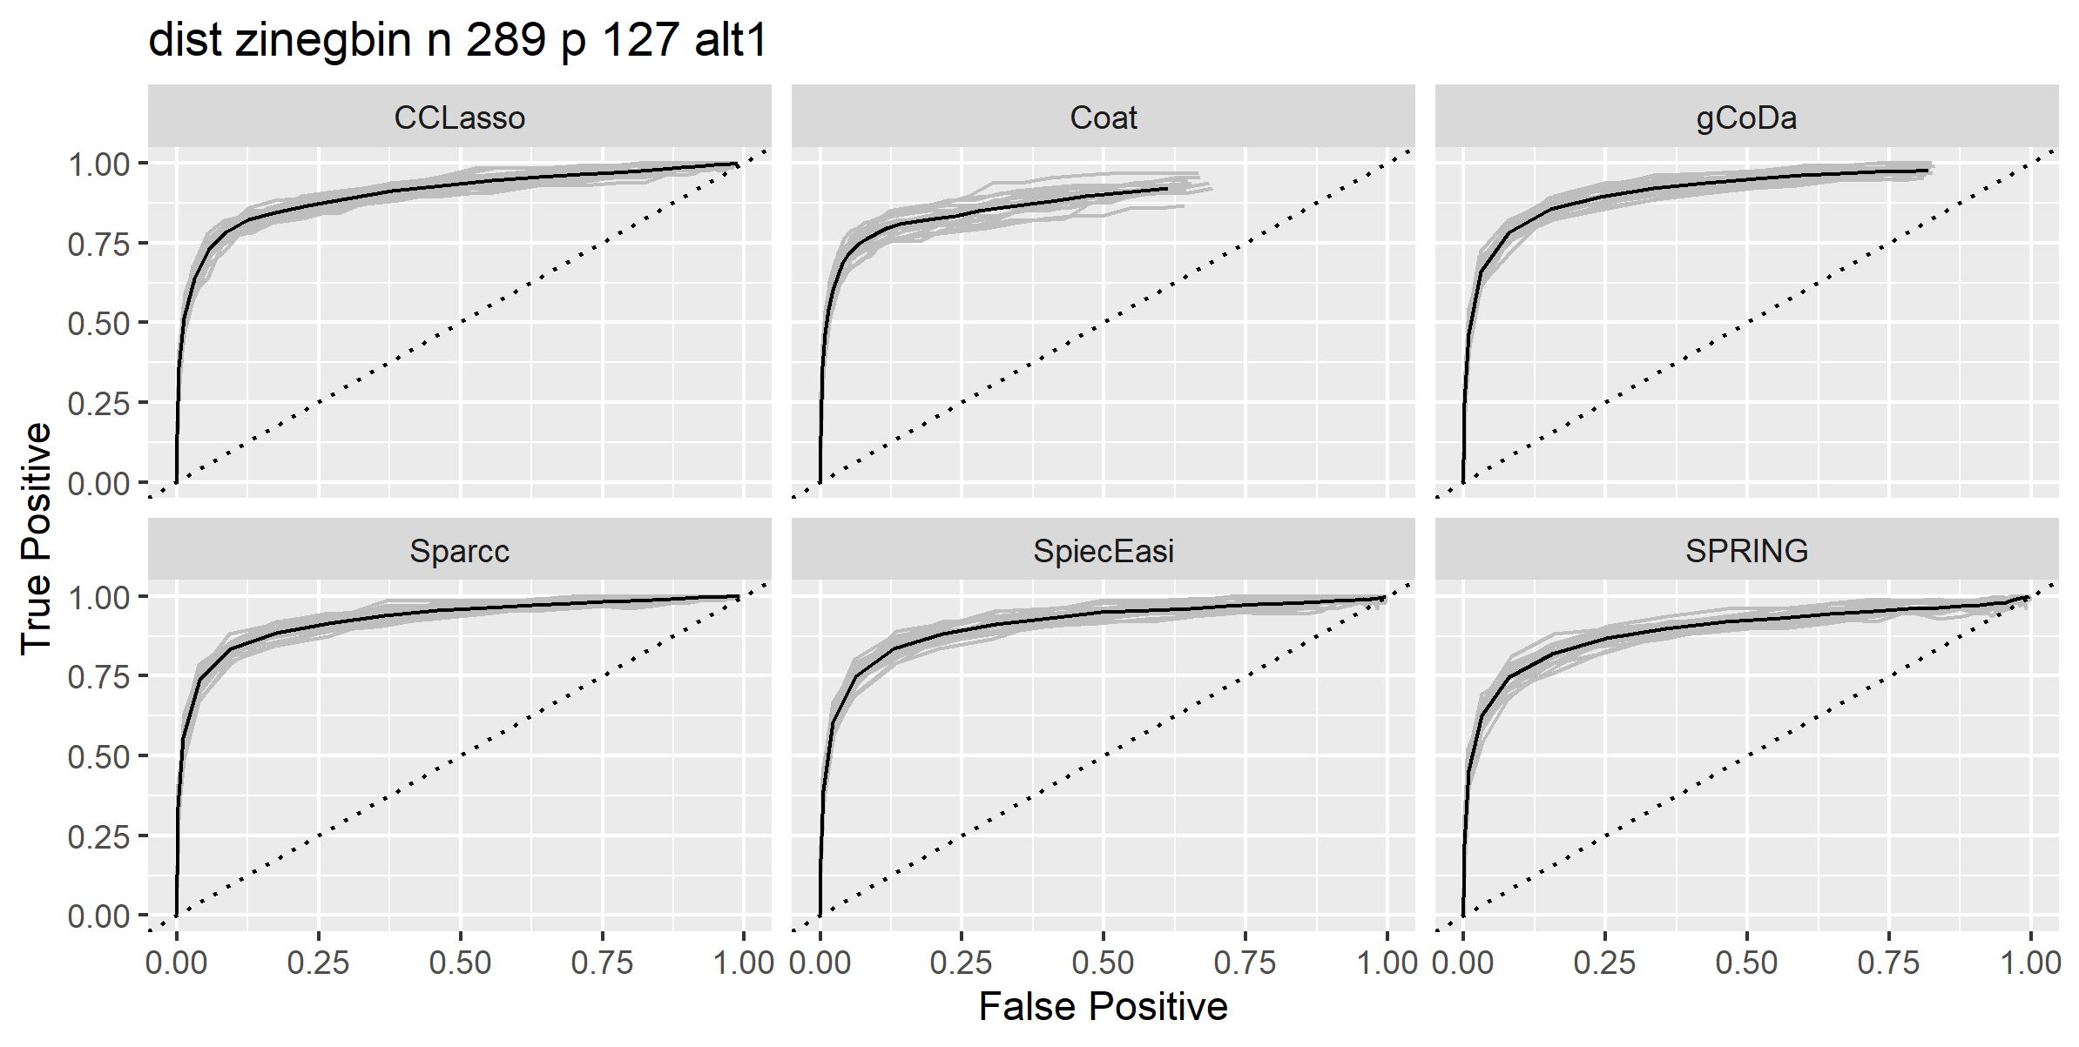

* 1. Pois. None of the methods work

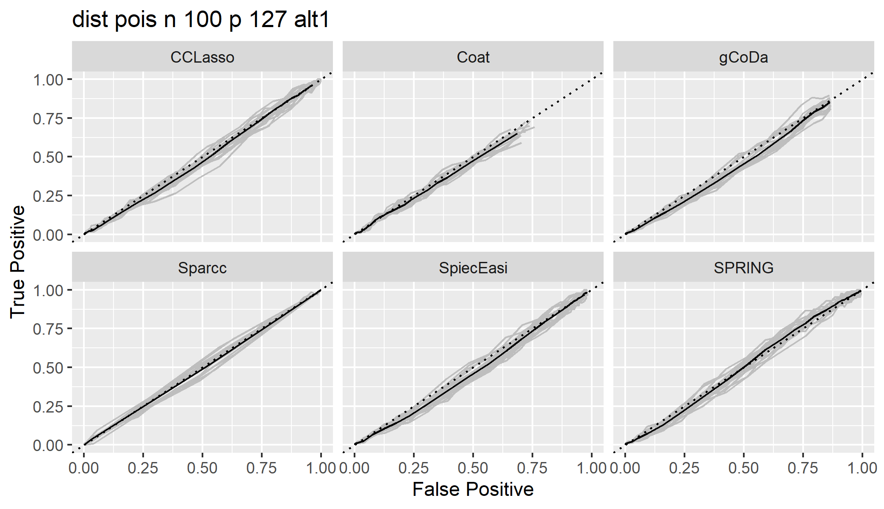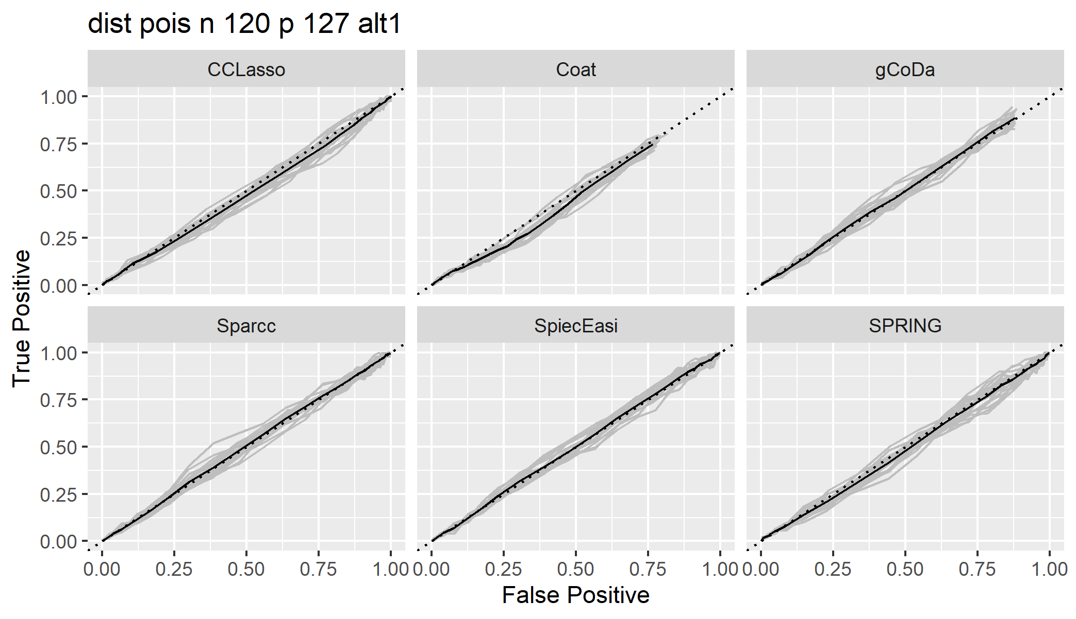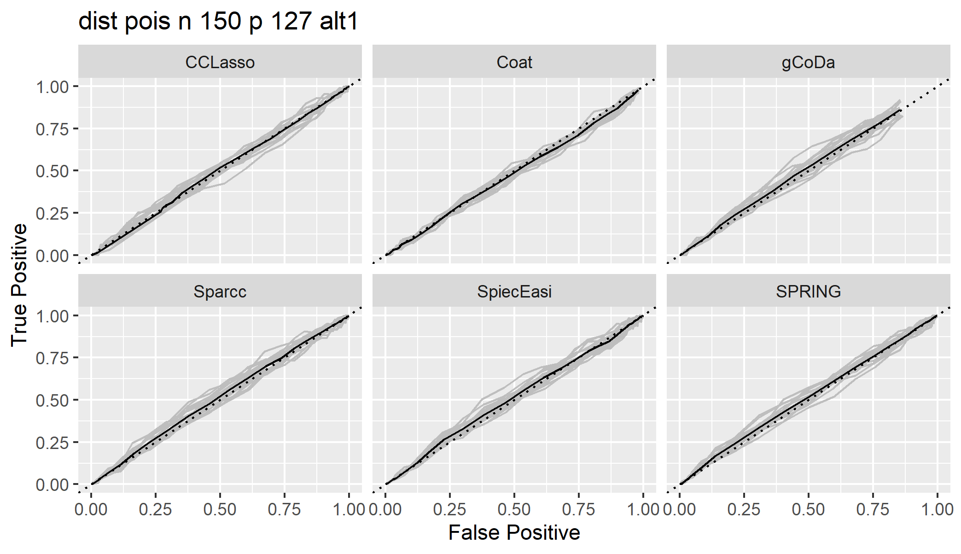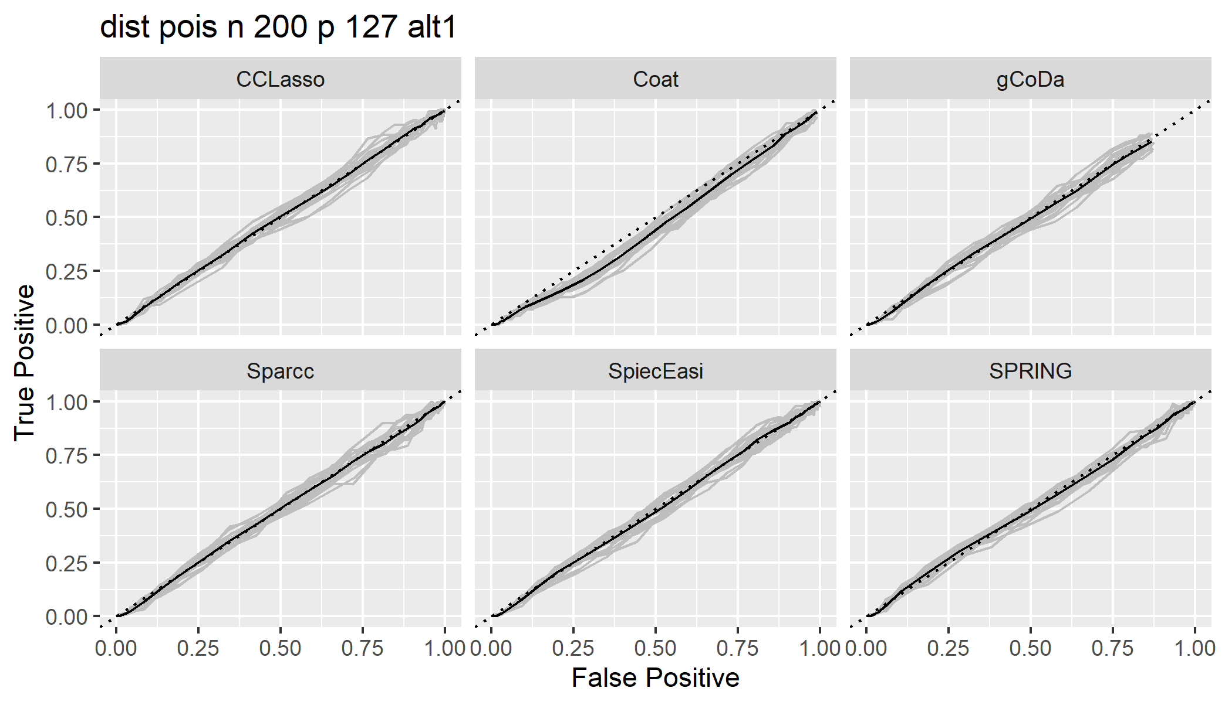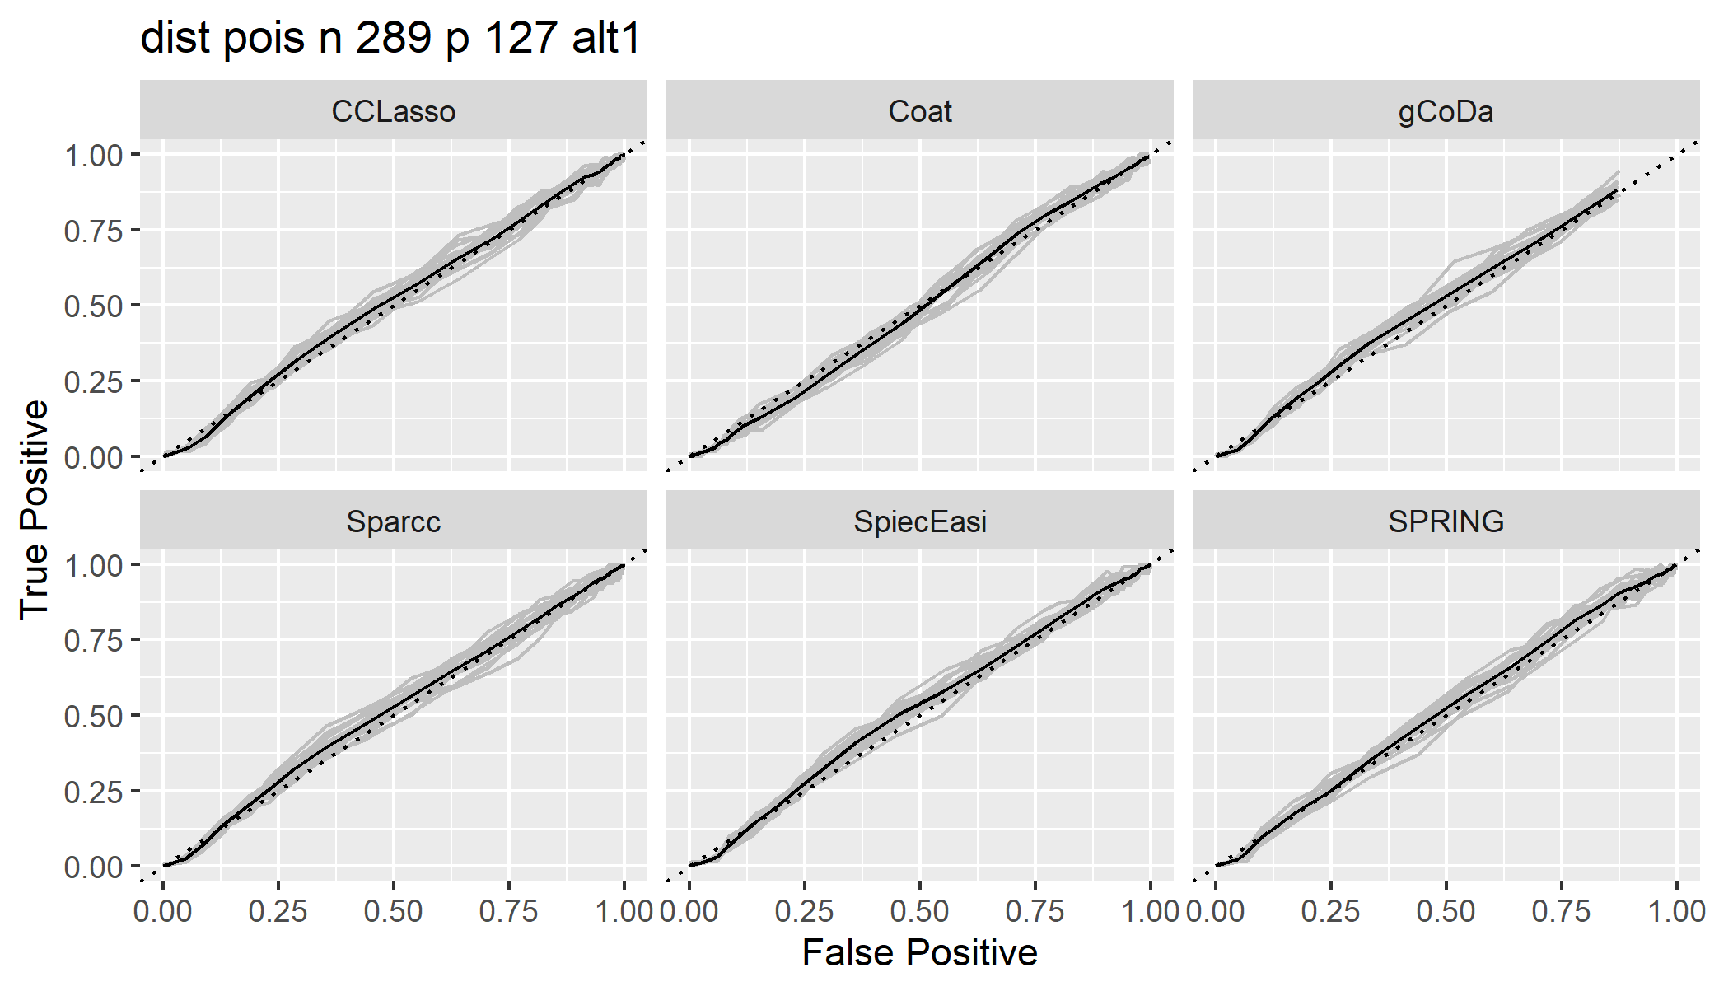

* 1. Negbin. Might need closer investigation for CCLasso and SparCC. The last plot for gcoda might have some error, not yet investigated.

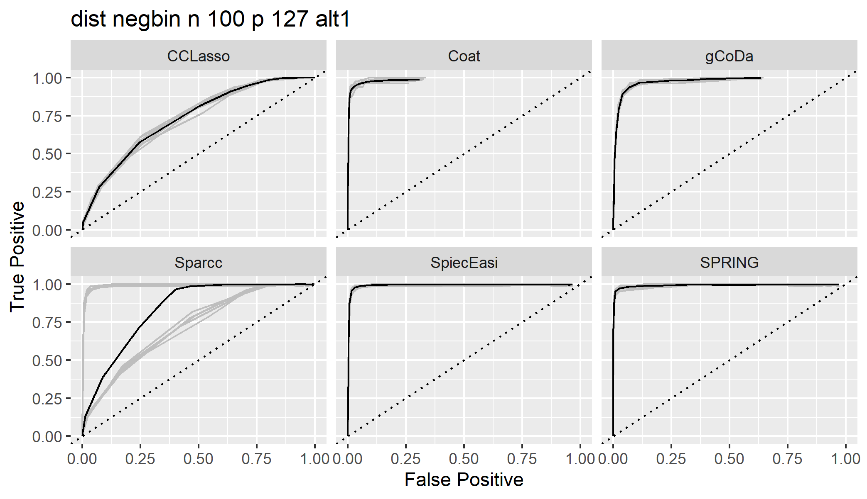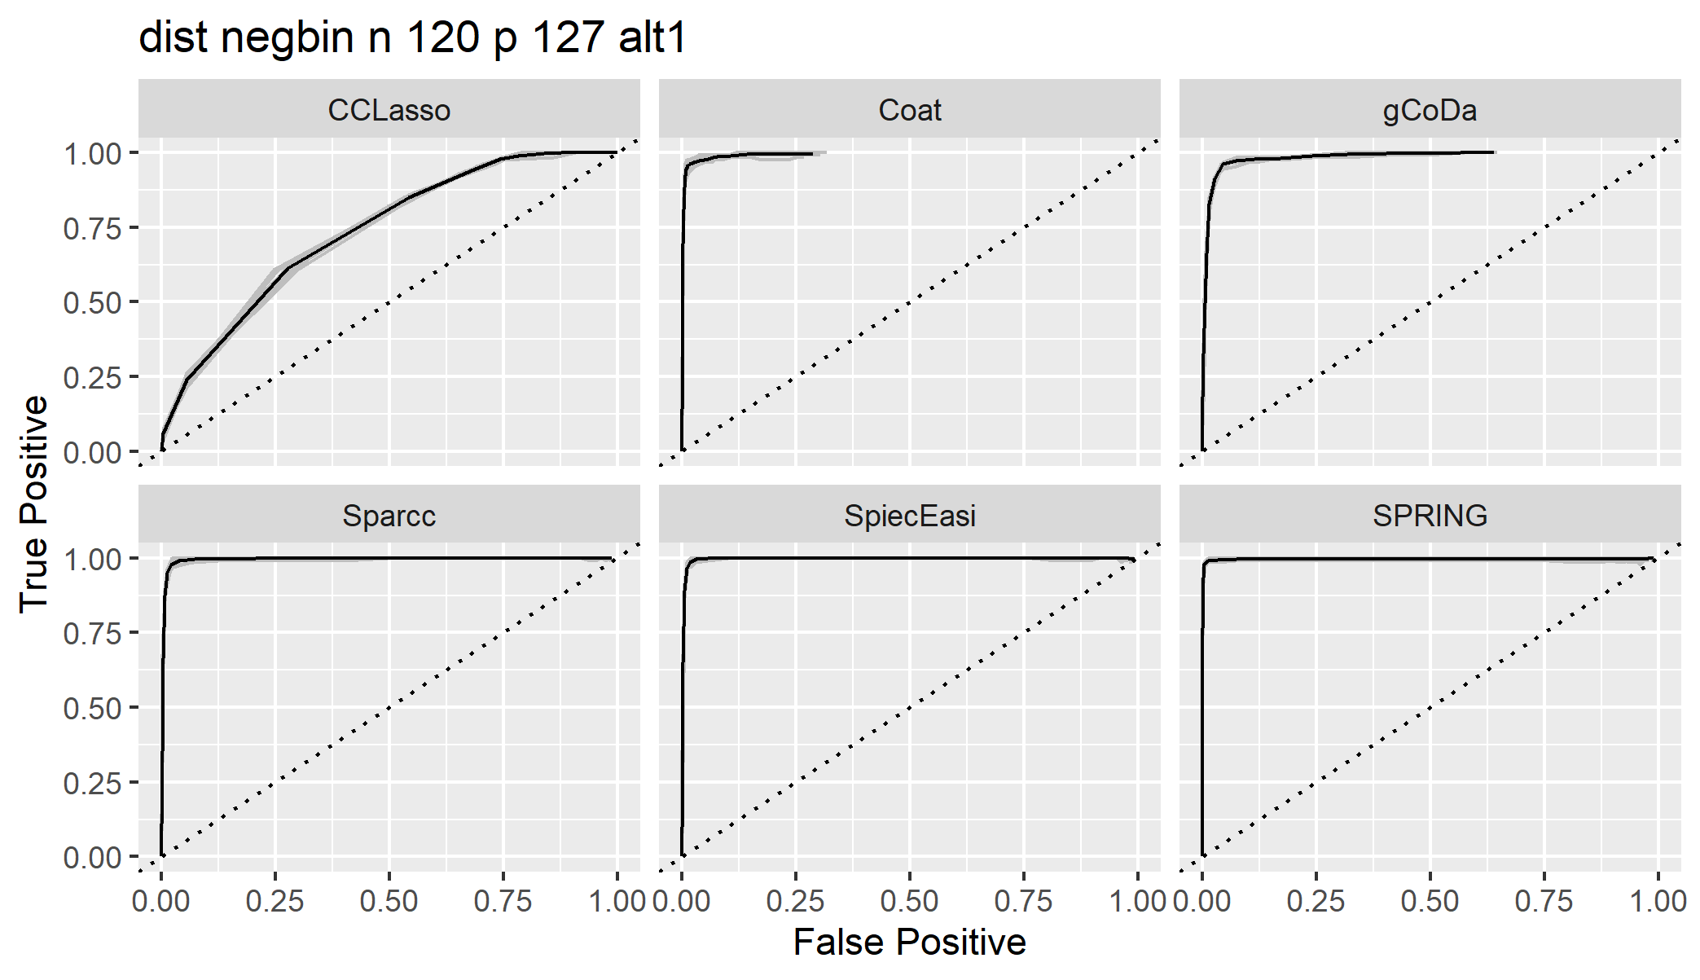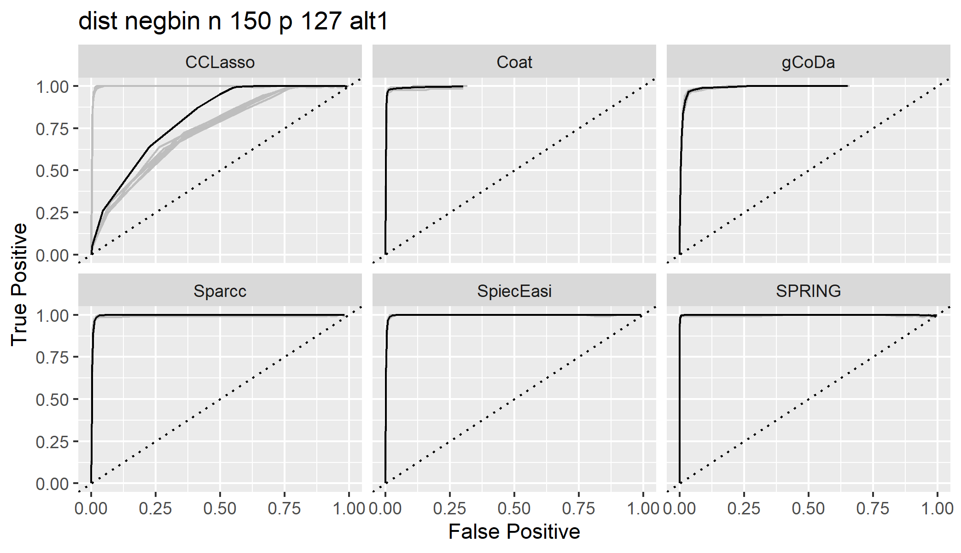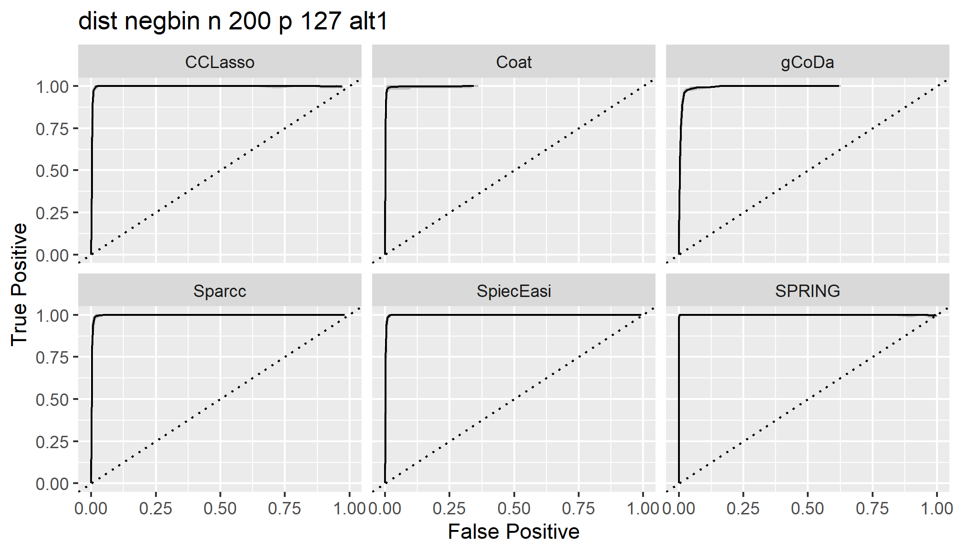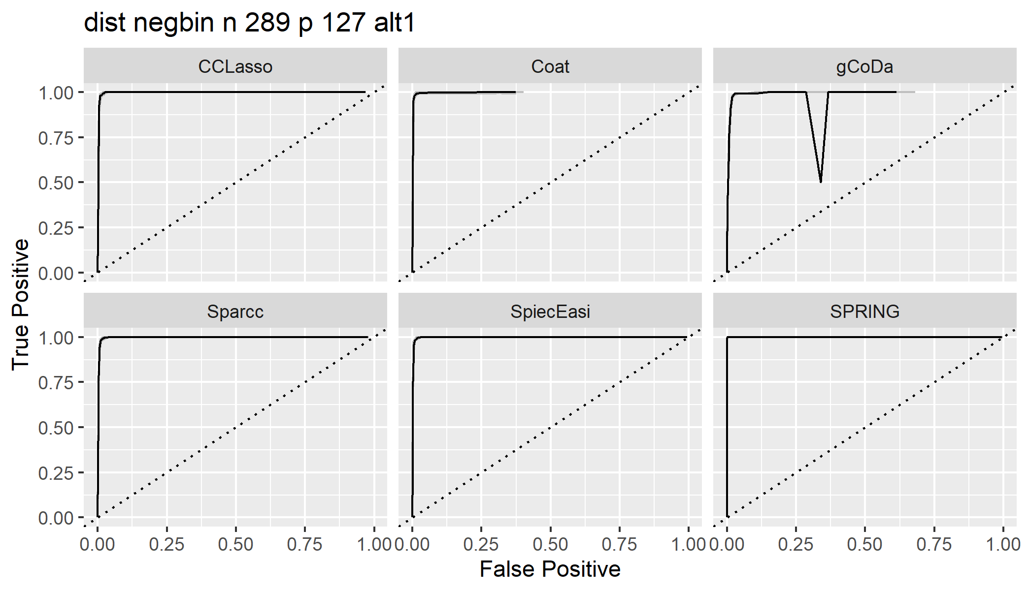

1. Alternative 2 model, generate from log normal model. Plot the mean ROC only for each p under the same n.
   1. did not use fixN/fix library size, using mu from uniform(0,4).

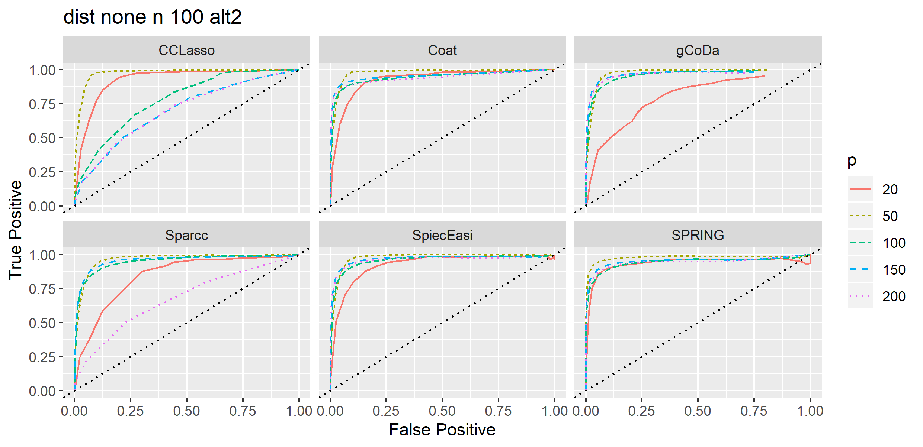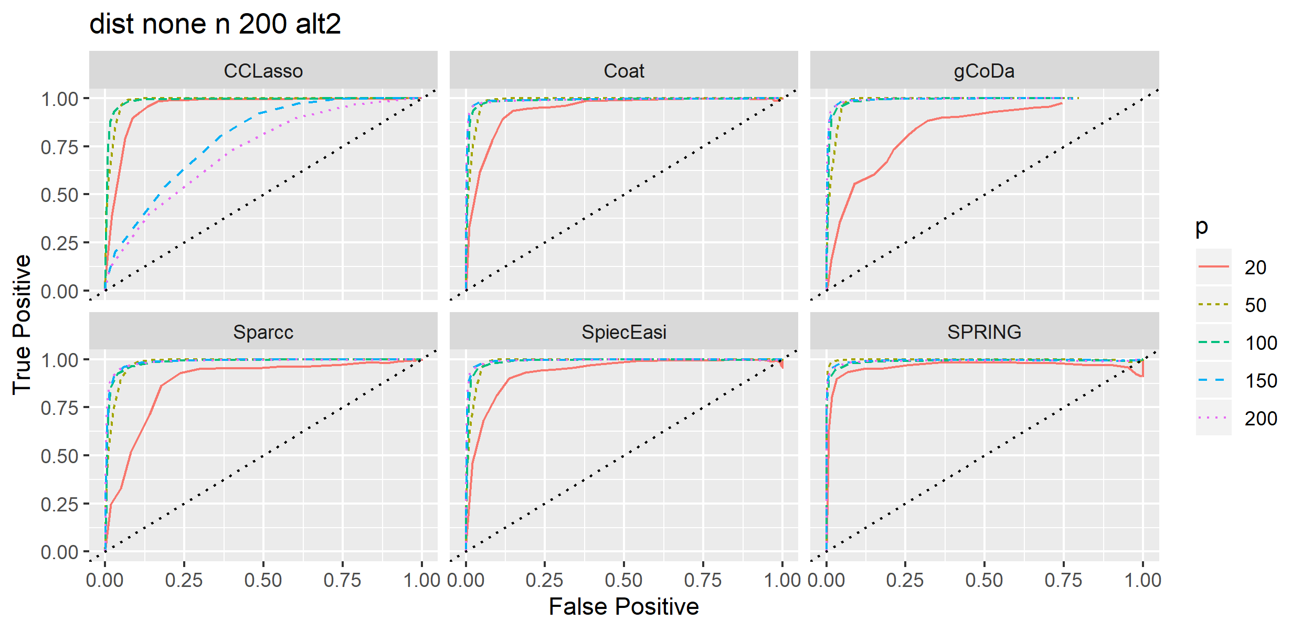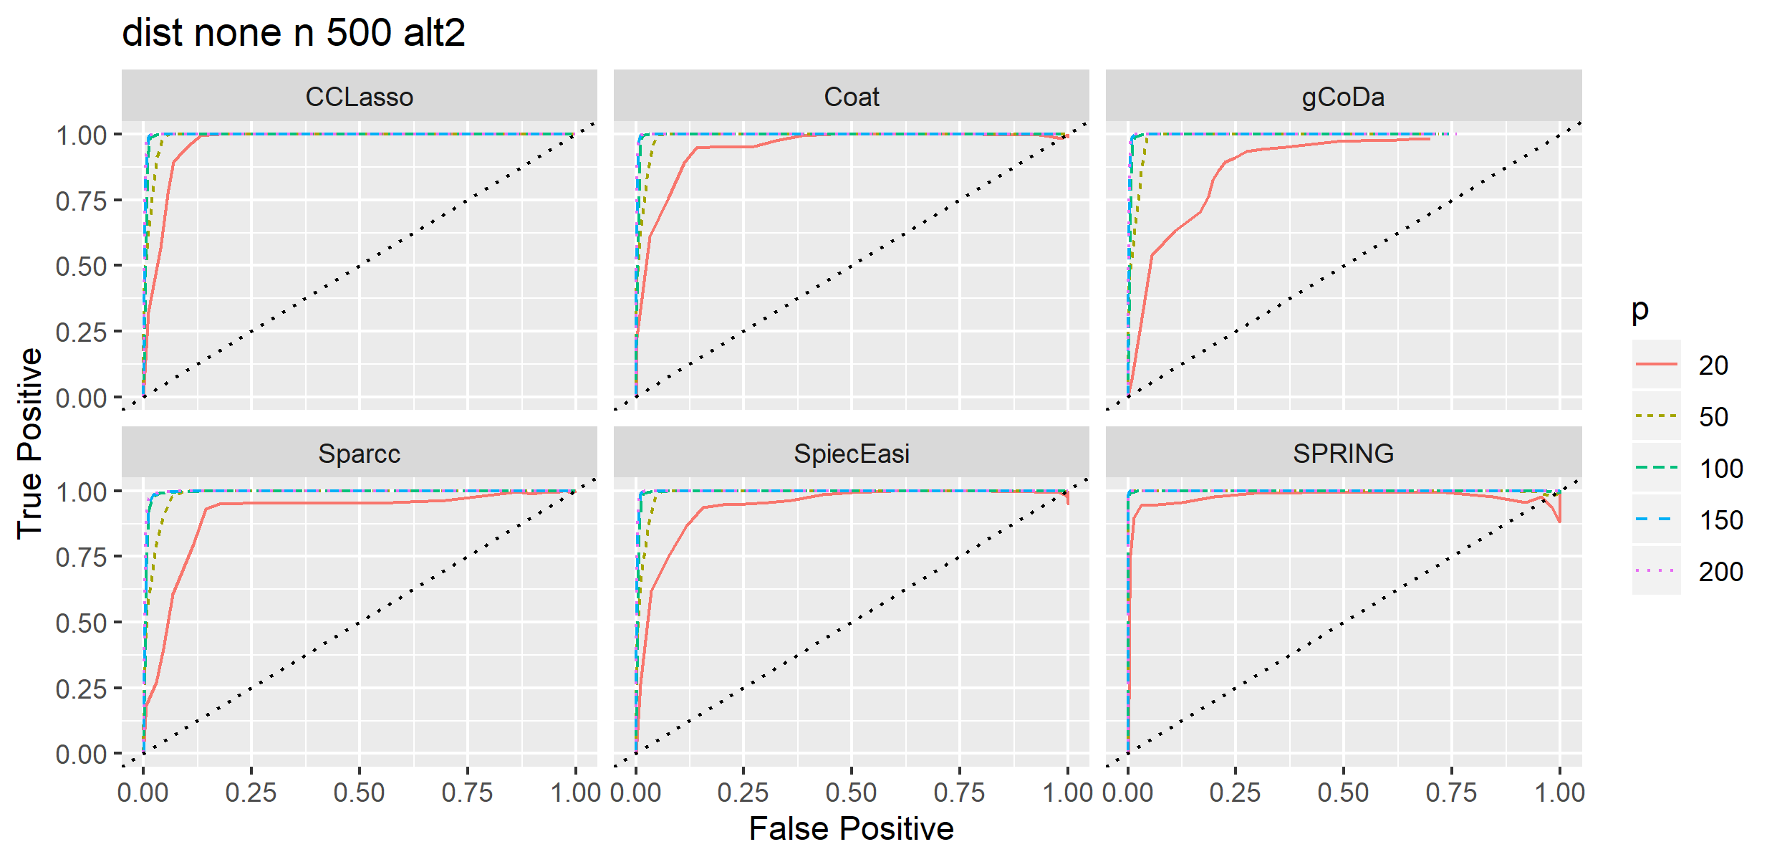

* 1. Use fixed library size, and also use mu~uniform(0,1): similar results.

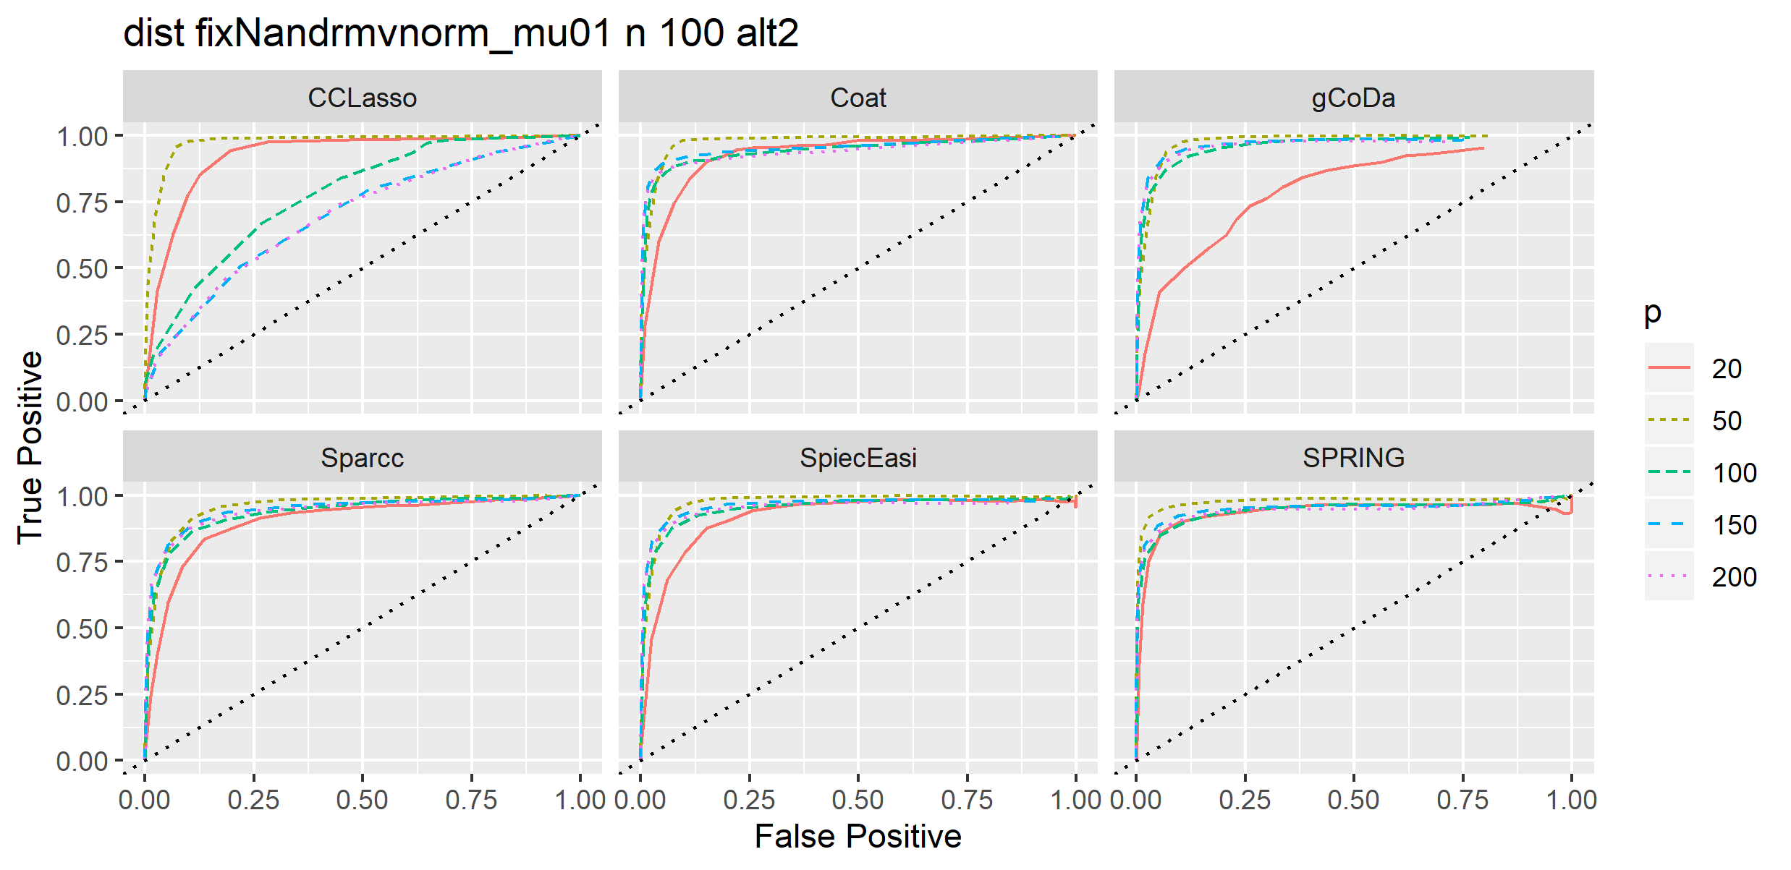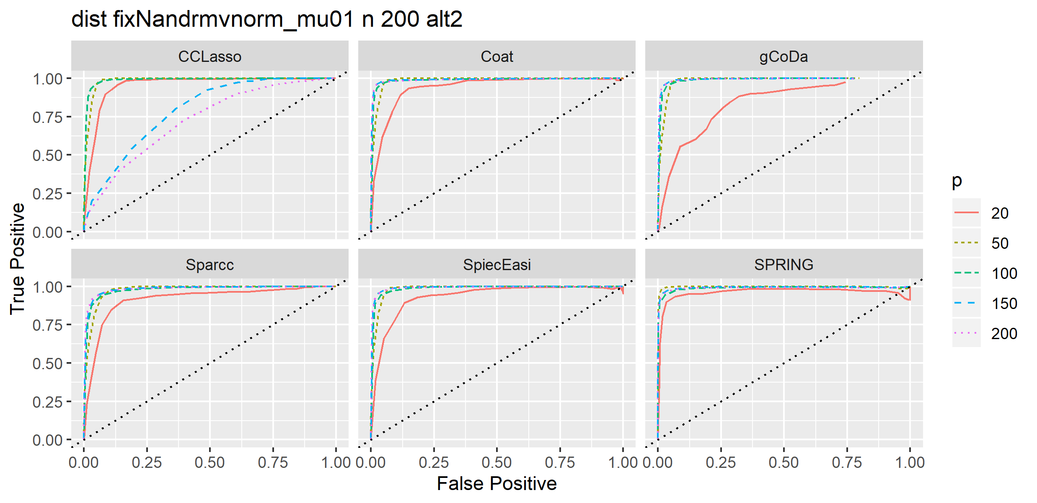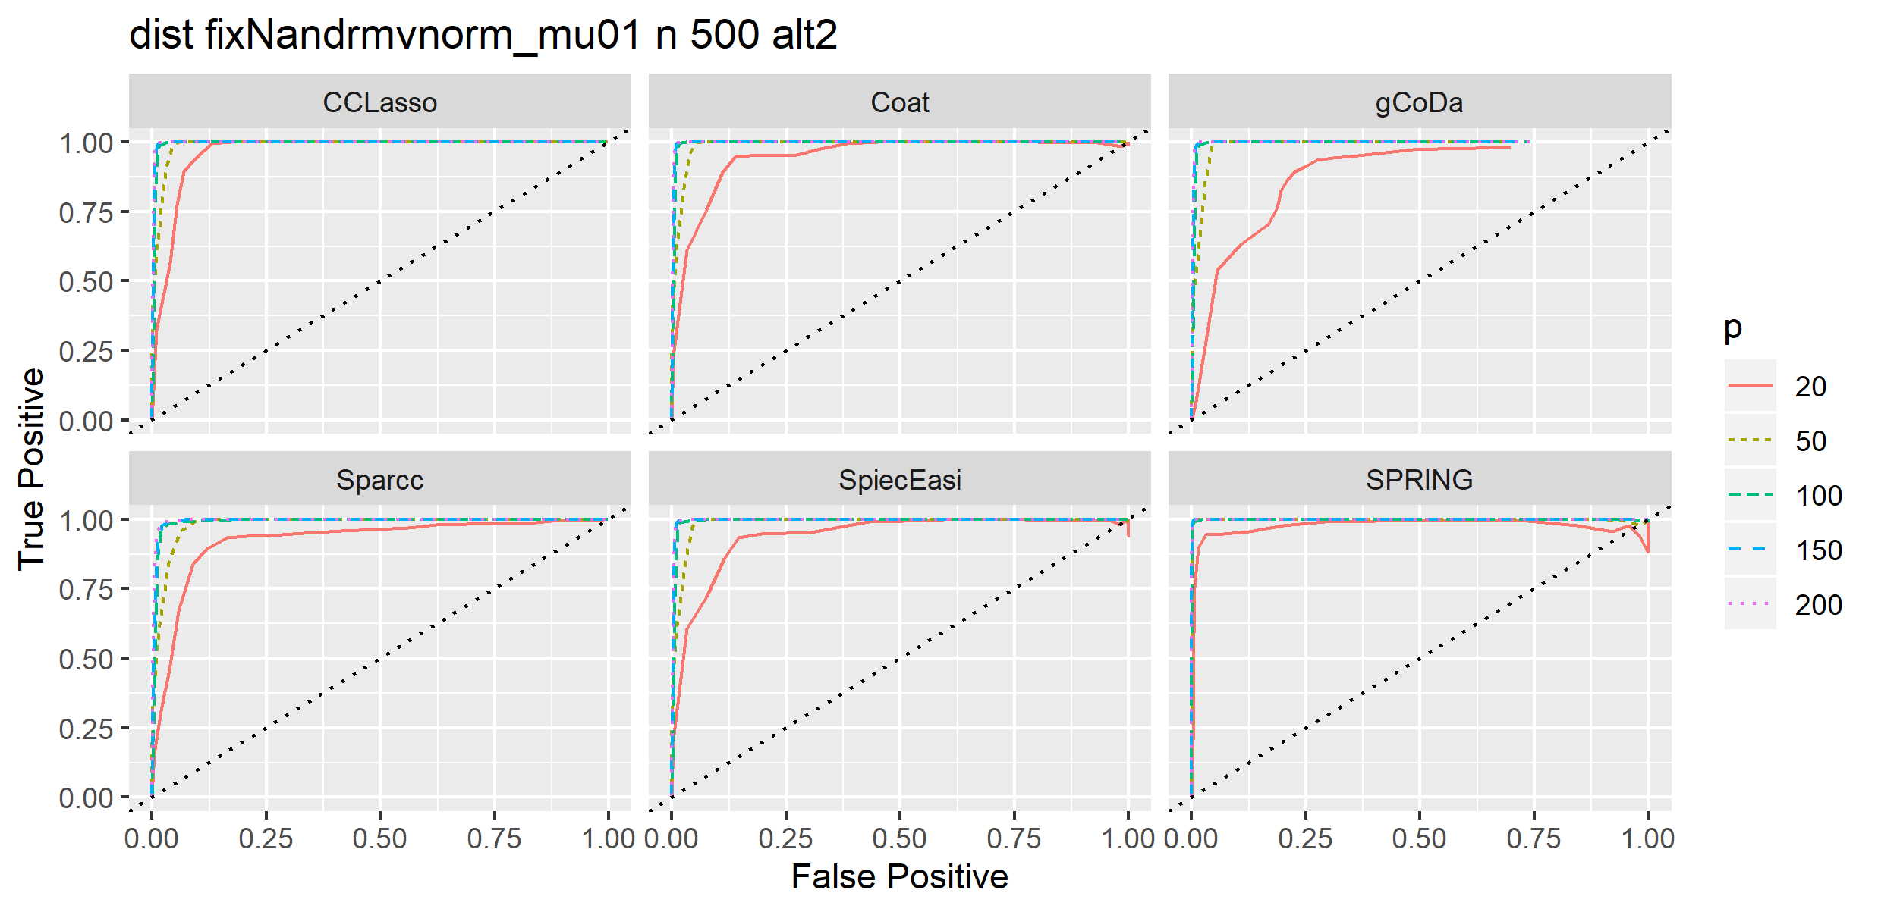

1. Some more exploration for CCLasso behavior under alt2, varying library scale and mu~uniform(0,4):

Tuning parameter by CCLasso is not at the boundary (assume no issue here)

By separately looking at each n p combination, the grey lines represent ROCs from different replicates. For these replicates tuning parameter is fine (not at the boundary supplied). However we can see large variation in ROCs.

